Naturalist Committee History 1972-1999 By: Joe Toynbee
The Naturalist Committee of the Mountaineers had its birth in August of 1972. Several Mountaineers who had been active members of the existing Botany Committee gathered in the living room of Dina Chybinski in Southeast Seattle. The feeling was that the term “botany” was too restrictive, and that other natural phenomena such as birds, mushrooms, and geology were also worthy of study. A proposed Naturalist Charter was presented to, and approved by, the Board of Trustees in September of 1972. Dina Chybinski was selected as the first Naturalist Chairperson.
The Naturalists were planned to operate somewhat differently than other Mountaineer groups. The primary focus was to be what was encountered along the route, and not the destination. Time allowances would be made for those who wished to look up a flower in a guidebook, take photographs, etc.
The first Naturalist entry in the Mountaineer appeared in November of 1972, and read as follows:
“NEW! NATURALISTS
To reflect the widening interest in all phases of natural history among the Mountaineers, the Botany group will be functioning under a new name: NATURALISTS. Now, lectures and field trips can touch on all aspects of outdoor lore, from archaeological digs to weather-watching. If you have training or hobby interest, a collection to exhibit, or a field trip to suggest, please send a postcard to Naturalists, c/o clubroom or phone Coordinator Dina Chybinski, 725-9081. And plan to meet fellow Birders, Rockhounds and Nature Watchers at our Christmas lecture-meeting and cookie spree, Wednesday evening, December 13.”
The first Naturalist event was the cookie-spree mentioned above. The following year of 1973 featured a full schedule of Naturalist activities. The first field event occurred on Sunday, February 11 and was a trip to Point Defiance Park in Tacoma. Dina Chybinski conducted a tour of the Aquarium, and Joe Toynbee led a five mile hike around the Point Defiance Peninsula.
The first Naturalist instructional evening at the clubhouse occurred on April 8, 1973: an introduction to plant identification conducted by Mary Fries. Another high point of the year was the first Naturalist backpack in late July. This was the Ross Lake-Beaver Loop from July 29 to August 3, and was to focus on “the study of ecosystems that would be drowned by the proposed Ross Dam elevation.” The participants travelled by boat up Ross Lake to Little Beaver Landing, and then hiked up Little Beaver Creek to Whatcom Pass, and then down Big Beaver Creek to Big Beaver Landing. The flowers on the trip were numerous: unfortunately the flies and mosquitoes were also prolific.
Other Naturalist trips of interest in this first year of operation included a trip to the Skagit Game Range for water birds, an overnight stay at Irish Cabin, a backpack up the Elwha River, and a Vegetation Tour up Kautz Creek at Mt Rainier. The year ended with another Cookie Spree at the Clubroom, featuring a talk on “Northwest Animals in Winter” by Jack Simmons, Naturalist Guide at Woodland Park Zoo. The MusicMakers provided Christmas music.
The year 1974 featured events such as a Bunny Hop in the Arboretum where “rabbits may be seen cavorting” and an Owl Prowl in Seward Park, with owl hoots played on a recorder to try to get an answer. There were evening programs such as “Bugs About the Mountain” on high altitude insects. The summer backpack was an eight day trip over LaCrosse Pass and the First Divide, ending at Staircase. On the second day of this trip a party member, Larry English, lost all his food which he had hanging in a tree to a very long armed bear.
For the past several years, the Naturalist activity year has centered around five events. First in late February is a bus tour of the Skagit Delta and adjacent areas to study waterfowl, in particular the snow geese. In April the wildflower workshop is presented at the clubhouse, a very popular event which covers the fundamentals of wildflower identification. Then in May or June an overnight weekend trip is taken to Coleman Leuthy’s ranch in the Eagle Creek valley north of Leavenworth to study eastside flowers and birds. In late August the Naturalists journey to Mt Baker cabin to examine late summer mountain flora. Finally in early December the annual Naturalist Christmas party is held at the home of one of our members. In addition to these events, many Naturalists camp out at Wenas Creek campground over Memorial Day weekend with the Audubon Society to study spring birds.
Dina Chybinski served as Naturalist Chairperson from 1972 to 1976. Subsequent chairpersons and their term of office are:
Roger Illingworth 1976-1984
Joe Toynbee 1984-1987
Irene Peters and Kathe Stanness 1987-1993
Virginia Gill 1993-1997
Joe Toynbee 1997-1999
Naturalist activities are planned at a quarterly Leader’s meeting in the Mountaineer clubhouse. At this meeting the Naturalist schedule for the following quarter is put together from a combination of information sent to the Hike Coordinator before the meeting and input at the meeting itself.
The Naturalists enter the second quarter century with pride in what they do. The focus on nature fills a vital niche in the range of Mountaineer activities.

We are not quite sure who the committee chair(s) from 2000 thru 2003 was/were. Don remembers that the group had shrunk and many of the participants were getting to the point that they could not be as active as they had once been.
Pat Zeisler and Noreen Edwards were the Naturalists Committee Co-chairs in 2004-2005.
******************************************************************************************
Don Schaechtel was chair of the Naturalists Committee from 2006-2009 During those years, the Introduction to the Natural World course was the committee focus, with the addition of several presentations and Naturalist hikes during the year. The Study Group was started in 2006.
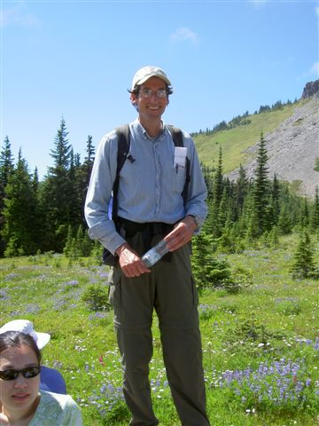
Don Schaechtel remembers:
In his Naturalist history, Joe did not mention Ruth Munson, who led the wildflower identification class when Ann and I took it in the 90s. Ruth was the resident botanist of the group (and a WNPS member). Another accomplishment of that era was a guidebook and kiosk for the Asahel Curtis Nature Trail near Snoqualmie Pass.
I approached the Naturalists Committee in 2004 with the idea of offering a natural history course along the lines of the scrambling and climbing courses, with lectures and field trips. They were skeptical that the course would attract participants, since the number of people who attended the annual wildflower workshops was declining. But they gave the go-ahead to give it a try. In a discussion about what to call the course, John Martin said, "It is really an introduction to the natural world," and we all agreed that would be a great course title.
Ann and I organized the first "Introduction to the Natural World" course in 2005. We chose the "Field Guide to the Cascades and Olympics," by Stephen Whitney and Rob Sandelin, as our course text and recruited Rob to give one of the presentations. Ed Dominguez joined us as a course instructor and field trip leader. Everyone was surprised and alarmed when 65 members signed up. We were able to deliver a good course, with five presentations, five field trips, and a fall reunion and award potluck dinner. The course ran from May to July so participants could see different plant communities at their peaks. Highlighted plants and animals were trees, shrubs, flowers, birds, reptiles, amphibians, mammals, and butterflies. Geology was also discussed in the first year. The sole graduation requirement was to submit a list of at least 100 species of plants and animals that were seen on their trips. Half the class submitted species lists for graduation.
After the course finished, there was a lot of enthusiasm among the graduates to stay involved in Naturalist activities. We formed a "Study Group," in 2006 with lifetime membership for a modest registration fee. The Study Group hosted a few presentations during the year and members were invited to join the next year's presentations and help as leaders or assistants on field trips. This built a corps of volunteer leaders in the Mountaineers tradition.
The Introduction to the Natural World course continued with improvements added each year. Course capacity increased to 80 as Study Group members gained confidence in leading.
In 2006 we hosted Kathrine Glew, a PhD lichenologist from the University of Washington. She gave a nice presentation about lichens, and when I got home I discovered that I had many lichens in my yard that I had never noticed before. Katherine told us about a multi-night workshop she was offering at UW, and four of us signed up: Don and Ann Schaechtel, Linda Rantala, and Jordan Roderick. The workshop included a field trip to Pack Forest near Mt. Rainier and we were amazed at the number of lichens we found. We were encouraged to collect some and bring them to the next workshop session to identify them to the species level.
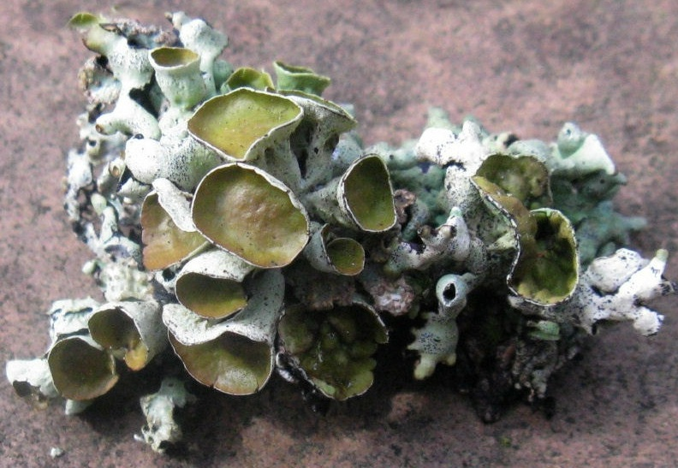
Our reference was Macrolichens of the Pacific Northwest, by Bruce McCune, which is a great resource, though it may be a little technical for beginners. I started using that book to identify lichens I found on my hikes and ski trips. I continued to be amazed at how lichens were everywhere and had just been part of the scenery until then.
In 2008 I hosted the first lichen workshop to share what I had learned with others. Call it lichen evangelism. Since we had learned the value of having specimens in hand, I designed the workshop so participants could make their own study aid with real lichens. I chose ten lichens that were common in the Pacific Northwest. Ann and I set about collecting enough so everyone could have ten specimens. We found some near our home in West Seattle and also took a memorable snowshoe trip to Meany Lodge, where we collected Alectoria, Platismatia, Bryoria, and Hypogymnia. On the way down we met some curious snowmobilers who wondered why two people were snowshoeing down the road carrying full Nordstrom's shopping bags.
For the workshop, as each participant came in, they picked up a specimen of each lichen species, a piece of posterboard, and a handout with a matrix with information about each lichen species. Participants sat at round tables, with their lichens in front of them, so they could share their observations with others. On each table we put a few branches with multiple lichens as centerpieces. I gave a 30-minute presentation about lichens in general, then we talked about each of their species and how to identify them. Participants were then asked to arrange and label their lichens on the posterboard. We had hot glue guns so they could glue them in place.
I have done this workshop with other groups since then and it is always fun and well-received. It is gratifying when people tell me, years later, that they still have the ID guide they made in the workshop (that just happened today, as I am hosting a "snowshoe lichen romp" for WNPS next month and started taking signups yesterday). The Wenatchee River Institute has even adapted the lichen workshop for one of their youth activities. It is also gratifying to know that the workshop remains popular with the Mountaineers.
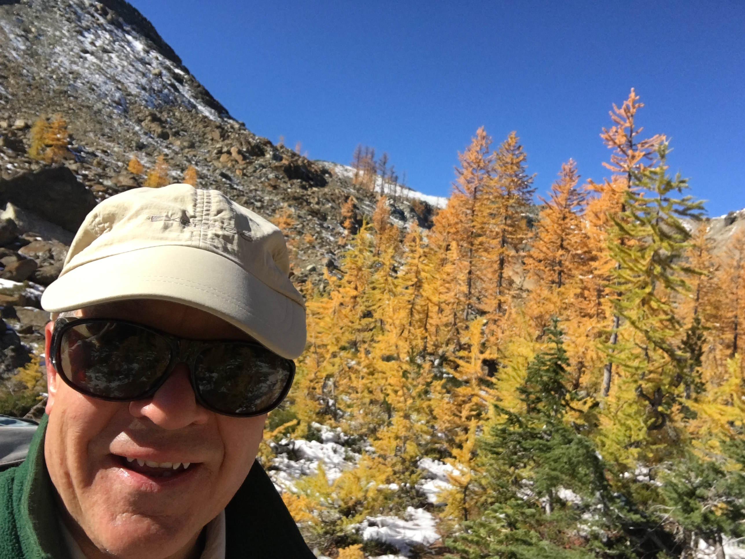
David Shema was Naturalist Chair 2010-2011 He remembers:
I went through the Natural World Course in 2006. This was my first introduction to the natural world.
In the spring of 2009, the Mountaineers’ Naturalist Committee began work to prepare for the creation of a native plant garden on a slope south of the new Mountaineers building. Goats were brought in to munch the blackberries. To keep the blackberries from coming back, volunteers laid down a barrier of cardboard and burlap and woodchips. The barrier left untouched for the next 12 months as it blocked the blackberries and slowly decayed.
Over 800 hours of volunteer support was logged in the creation of the native plant garden.
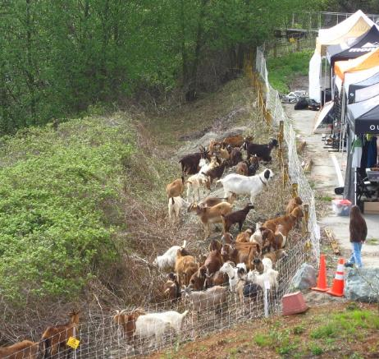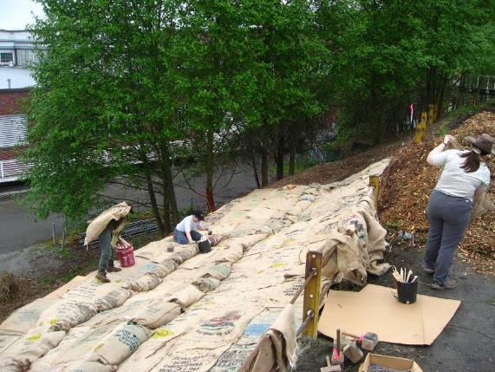

February 2010 – Sunny Walter passes. Sunny was a long-time active instructor and participant with the Seattle Mountaineers Naturalists committee.
May 2010, in partnership with the Washington Native Plant Society and the Light Table Design Collective, the Naturalists designed the lower section of the native plant garden on top of what previously had been pavement.
May 2010 – About 88 were enrolled in the Introduction to the Natural World course this spring. The lectures and field trips were well attended.
September 2010 - 38 students graduated from our course. The sole graduation requirement remained unchanged from the previous year: submit a list of at least 100 species of plants and animals that were seen on their trips.
October 2010 - Planting of trees and shrubs began on the slope section of the native plant garden that once was a blackberry thicket. The cardboard, burlap, and woodchips had done their job – the blackberries were gone.
At the same time, at the base of this slope, yards and yards of topsoil and mulch were brought in and sculpted into berms and mounds to create the lower (and flat) section of the Native Plant garden. Planting of flowers and shrubs in this lower section began soon after.
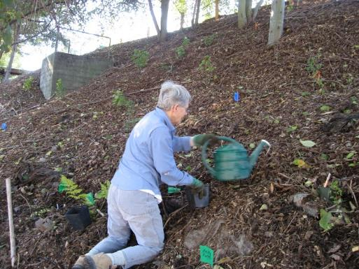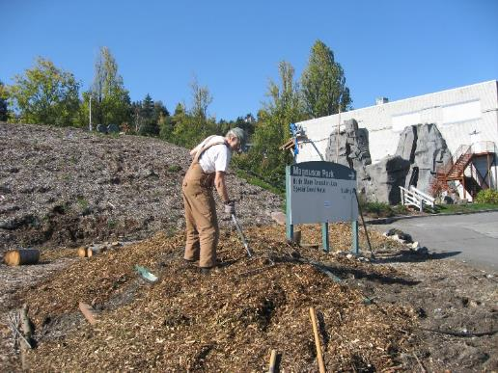

May 2011 - 63 students enrolled in the Intro to the Natural World course. Again, the lectures and field trips were well attended.
September 2011- 21 students graduated from our course. The sole graduation requirement remained unchanged from the previous year. We are not sure why so few students submitted a list of plants in 2010 and again in 2011.
September 2011 – Naturalists had a booth at the first-ever Mountaineers Outdoor Fest. We gave tours of the native plant garden.
2010-2011, the Naturalist committee experimented with surveys to recruit new committee members, instructors, and native plant gardeners. The Lichen Seminar continued with the help of Don Schaechtel and Cindy Luksus. Lectures were held throughout the year for the general public and study group members.
Notable volunteers in 2010-2011 were: Heidi Diem, Cindy Luksus and Bill Deters, Gini Tripp, Ed Dominquez, Linda Moore, Vicki and Jim King, Gordie Swartzman, Stuart Hougen, Don & Ann Schaechtel, Mickey and Jeanie Eisenberg, Kay English, Sandy Bowman.

*************************************************************************************
Cindy Luksus was Study Group Chair 2010-2011 and Naturalist Chair 2012-2013. Cindy remembers:
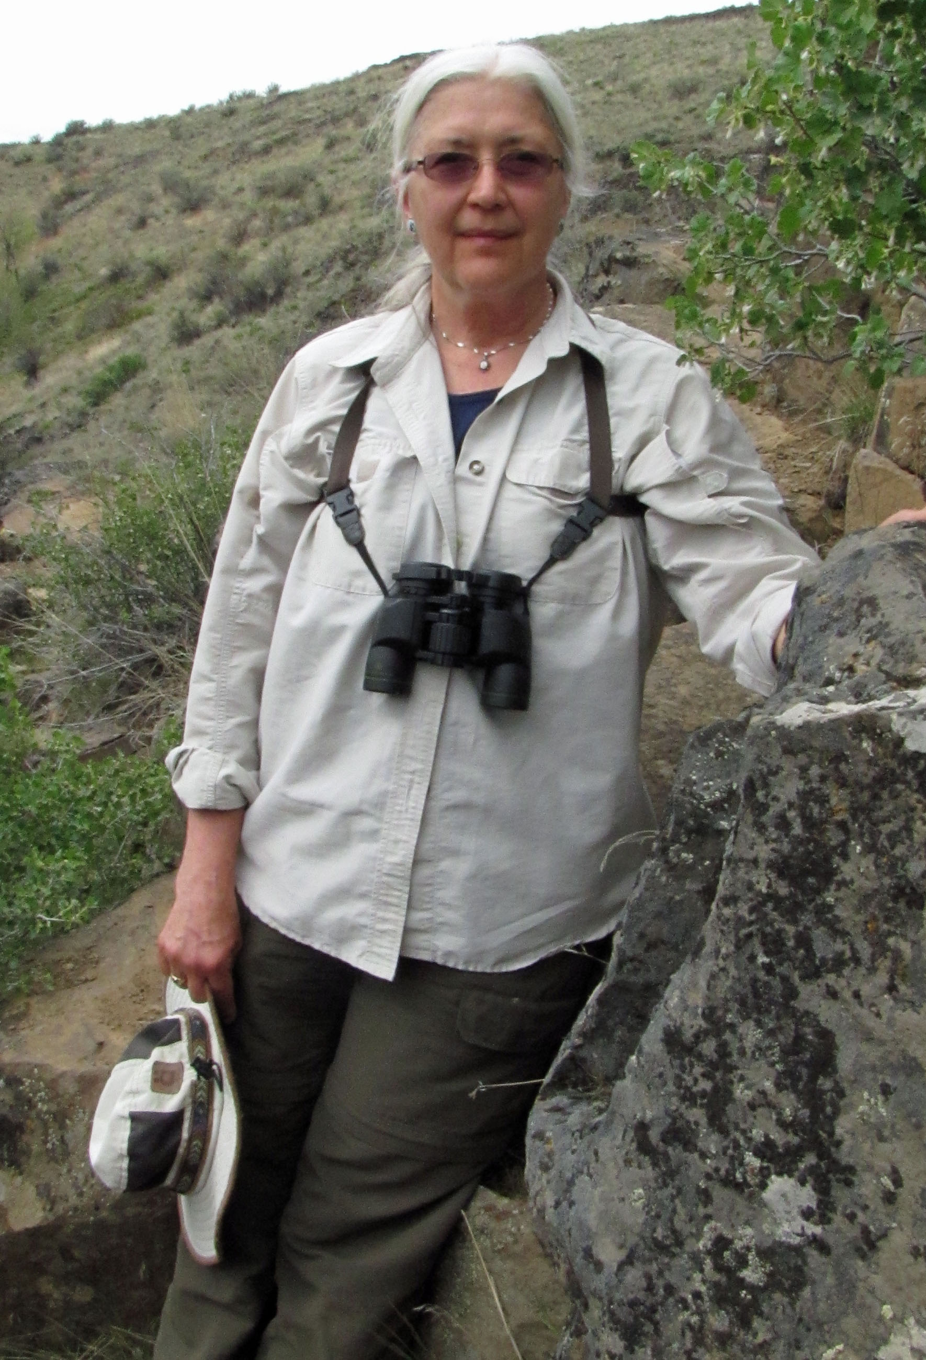
I went through the NW Course in 2006. Don and Ann Schaechtel had just started up the class the year before. They recruited me and my friend Gini Tripp to start leading FT’s. Well since we did not know that much ourselves we dived into a very intensive learning effort. We would scout out each trip beforehand and ID as much as we could by taking our field guides and our cameras.
By 2007 I joined the PNW Mycological Society. Took their classes and went on many of their FT’s. Did my first powerpoint presentation on fungi basics in 2009 for the Naturalist Class.
In 2010 I became Study Group Chair. We started a Study Group Newsletter (pretty crude compared to current standards), and initiated the first Lecture Series. For the 1st Lecture Series we had Clay Antieau, Paul Bannick, Chris Anderson, Dr Ralph Haugerud, and Constance Sidles come talk. The Series was aimed at the Study Group, but the public was invited. This Series was very successful and continues at the time of this writing (2023). We also initiated a Study Group Field Trip Committee and started to schedule regular FT’s for the Study Group
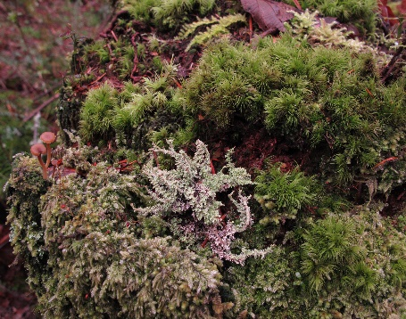
Around the time after Don Schaechtel took a course in lichens thru the ative Plant Society in 2007. He introduced me to my first lichen---Usnea---and I was hooked. Started taking pictures of lichen, took the Lichen Seminar led by Don and the Native Plant Society class. Met Richard Droker and became kind of a tag along member of the NW Lichenology Group. Learned much from those FT’s. For the 2011 Lichen Seminar I put together a powerpoint presentation and organized FT’s for the students who attended the seminar so that they could ID the lichens themselves in nature.

Well you can’t go out and study lichens without noticing their little green leafy counterparts, the bryophytes! Read everything I could find on them. Again the Native Plant Society was helpful with seminars. Even took a seminar down in Oregon sponsored by the Siskiyou Field Institute on Bryophytes. In late 2012 did a number of trips with Lynn Graff and we decided to put together a seminar on Bryophytes. It was done in the format of the Lichen seminar. We had a grand time trying to collect all of the sample mosses and liverworts! Because of the more fragile nature of these plants, we could not do a story board. We gave the students egg cartons and made them ID and label their samples. After the seminar we took the students on a FT to find and ID bryophytes in nature.
All classes stressed first morphology, then the importance of fungi, lichen, bryophytes. Next we gave an introduction of the more common of them. We also gave a list of books and field guides, and courses. It was a lot of work collecting all of the samples for the lichen and bryophyte seminars. The samples we collected were the most common, and we were always careful not to over collect from any one area. Having the samples for students to study under a hand lens and microscope was very instructive. The FT’s were very popular. We managed to get enough folks excited about the “little things” in the forest that they took the time to study and learn themselves. Study Group members, those listed above and more were super supportive and helpful. They did a lot to make the Naturalist Course and Study Group what it is today. I guess that is the Mountaineer way. It was very rewarding.
During my time as Chair, Gordie Swartzman assumed the jobs of Study Group Chair and leader of the Naturalist course---he did an excellent job. In 2012, 79 enrolled and 48 graduated. In 2013, 63 enrolled and 38 graduated.

Kay English was Naturalist Chair for 2014.
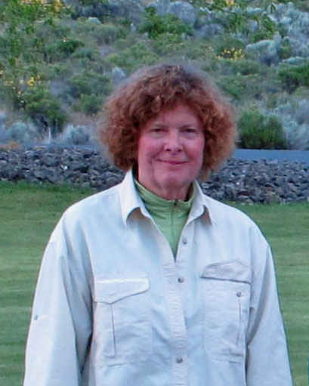
Gordy Swartzman continued on as Study Group Chair and Naturalist Course Lead.

